
Kudlu Gate, Hosur Road, Bengaluru – 560068
SCHOOL OF COMPUTER APPLICATIONS
A Project Report
on
Implicit Trust Signal Detection in Healthcare Chatbot Conversations using Natural Language Processing and RoBERTa
Submitted in partial fulfilment of the requirements for the award of the Degree of
MASTER OF SCIENCE (DATA SCIENCE)
Submitted by
ABED DANI.A(SCA25MSD002)
TAHA (SCA25MSD072)
IRFAN TK (SCA25MSD033)
Under the guidance of:
MS.SUMANA SG
June 2026
DAYANANDA SAGAR UNIVERSITY
Kudlu Gate, Hosur Road, Bengaluru – 560068


SCHOOL OF COMPUTER APPLICATIONS
BONAFIDE CERTIFICATE
This is to certify that the project titled "Implicit Trust Signal Detection in Healthcare Chatbot Conversations using Natural Language Processing and RoBERTa" is a bonafide record of the work undertaken by << Name of the Student >> (USN: << USN No >>) in partial fulfilment of the requirements for the award of the Master of Science (Data Science) degree at the School of Computer Applications, Dayananda Sagar University, Bengaluru, during the academic year 2025–2026.
GUIDE DEAN
<< Guide Name and Designation, School of Computer Applications, Dayananda Sagar University, Bengaluru >>
Dr. S. Senthil, Professor and Dean, School of Computer Applications, Dayananda Sagar University, Bengaluru
Project Viva-voce held on ______________________.
Internal Examiner External Examiner


SCHOOL OF COMPUTER APPLICATIONS
DECLARATION
I, << Name of the Student >>, a student of the Master of Science (Data Science) program at the School of Computer Applications, Dayananda Sagar University, hereby declare that this project, titled "Implicit Trust Signal Detection in Healthcare Chatbot Conversations using Natural Language Processing and RoBERTa", is the result of my independent work carried out under the supervision of << Guide's Name and Designation >>.
I am submitting this project work in partial fulfilment of the requirements for the award of the Master of Science (Data Science) degree by Dayananda Sagar University, Bengaluru, for the Academic Year 2025–2026.
I further affirm that this project report, in whole or in part, has not been submitted for the award of any other degree or diploma at this or any other university/institution.
Signed by me on: ____________________
Signature of the Candidate
This is to certify that the project work submitted by << Name of the Student >> has been carried out under my guidance, and the declaration made by the candidate is true to the best of my knowledge.
Signature of the Guide
Date: ____________________

ACKNOWLEDGEMENT
I express my heartfelt gratitude to Dayananda Sagar University for providing an excellent platform to learn and grow, and for the unwavering support extended throughout my academic journey.
I extend my sincere gratitude to Dr. D. Hemachandra Sagar, Chancellor, and Dr. Premachandra Sagar, Pro Chancellor, Dayananda Sagar University, for their visionary leadership in fostering an environment of academic excellence.
I am profoundly grateful to Dr. B.S. Satyanarayana, Vice Chancellor, and Dr. Puttamadappa C, Registrar, Dayananda Sagar University, for their invaluable guidance in ensuring world-class education at the university.
I extend my heartfelt thanks to Dr. S. Senthil, Professor and Dean, School of Computer Applications, Dayananda Sagar University, for his valuable suggestions and constant support throughout this project.
I am deeply indebted to my guide, << Guide's Name and Designation >>, School of Computer Applications, Dayananda Sagar University, for continuous support, necessary advice, and invaluable guidance that shaped the outcome of this project.
I would also like to thank all the teaching and non-teaching staff members of the School of Computer Applications for their support during my academic tenure.
Lastly, I am grateful to my parents and friends for their unwavering support and encouragement throughout this journey.
<< Student Name >>
[USN No]

CONTENTS
CHAPTER 1: INTRODUCTION ......................................................................... 1
1.1 Project Overview
1.2 Software and Hardware Requirements
1.3 Functional and Non-Functional Requirements
1.4 Domain Profile
CHAPTER 2: LITERATURE SURVEY .............................................................. 4
2.1 Existing Research and Related Work
2.2 Gaps in Existing Systems
2.3 Overview of Technologies Used
2.4 Comparison of Different Approaches
CHAPTER 3: METHODOLOGY & SYSTEM ANALYSIS .................................... 9
3.1 Existing System
3.2 Proposed System
3.3 Datasets Used
3.4 Machine Learning Model/Algorithm Selection
3.5 Feasibility Study
CHAPTER 4: SYSTEM DESIGN AND DEVELOPMENT ....................................... 14
4.1 System Architecture (High-Level Design)
4.2 Detailed Design (Low-Level Design)
4.3 Database Design
4.4 Input/Output Interface Design
4.5 Module Description
CHAPTER 5: IMPLEMENTATION & CODING .................................................... 18
5.1 Programming Language and Framework Used
5.2 Algorithmic Approach
5.3 Code Snippets and Explanation
CHAPTER 6: SOFTWARE TESTING .................................................................. 21
6.1 Testing Strategies
6.2 Test Cases
6.3 Performance Metrics and Evaluation
CHAPTER 7: RESULTS AND DISCUSSION ....................................................... 23
7.1 Experimental Setup
7.2 Model Performance Analysis
7.3 Comparison with Existing Systems
7.4 Visualization of Results
7.5 Screenshots of Working System
CHAPTER 8: CONCLUSION AND FUTURE ENHANCEMENTS ......................... 28
8.1 Conclusion
8.2 Limitations of the Project
8.3 Scope for Future Enhancements
REFERENCES .................................................................................................... 29

Chapter 1
INTRODUCTION
1.1 PROJECT OVERVIEW
1.1.1 Statement of the Problem
Healthcare chatbots are increasingly used as a first point of contact for patients seeking medical guidance, vaccination information, and general health advice. While such systems are evaluated extensively for factual accuracy, far less attention is paid to the implicit trust signals that patients express during a conversation — the hedging, uncertainty, scepticism, or confidence embedded in their word choice. A patient who writes "I guess it could be correct but I am not convinced" is communicating a very different trust state than one who writes "Thank you doctor, that makes sense and feels reassuring", even though both may be responding to the same chatbot answer. Existing chatbot evaluation pipelines rarely capture this dimension, leaving a gap between what a system said and how much the patient actually trusted it.
1.1.2 Brief Description of the Project
This project implements an end-to-end Natural Language Processing pipeline that detects implicit trust signals in healthcare chatbot conversations. A fine-tuned RoBERTa transformer classifies each conversational utterance into Low Trust, Medium Trust, or High Trust categories. This transformer output is combined with a set of handcrafted, healthcare-specific linguistic features — trust/distrust lexicons, hedging and uncertainty markers, sentiment polarity, and prediction entropy — inside a transparent ensemble scoring function that produces a single, interpretable Trust Score between 0 and 100. The complete system, including data preprocessing, feature engineering, model training, evaluation, and explainability (SHAP), is implemented in a single Jupyter/Google Colab notebook, and a working demonstration is exposed through an interactive Streamlit web application deployed publicly using an ngrok tunnel.
1.1.3 Objectives of the Project
- To design and implement a preprocessing pipeline suitable for extracting implicit trust cues from short, informal healthcare-related conversational text.
- To construct a healthcare-specific trust/distrust lexicon and a rule-based weak-supervision scheme for generating pseudo trust labels in the absence of a manually annotated implicit-trust corpus.
- To fine-tune a RoBERTa transformer model for three-class trust classification (Low / Medium / High Trust) and to benchmark it against a traditional TF-IDF + Logistic Regression baseline.
- To quantify predictive uncertainty using Shannon entropy over the RoBERTa class probabilities and to combine it with handcrafted features into a single composite/ensemble Trust Score.
- To provide model explainability using SHAP for the baseline model and a transparent additive feature-contribution breakdown for the composite score.
- To deploy the resulting system as an interactive Streamlit dashboard, accessible publicly via ngrok, that displays the Trust Score, RoBERTa probabilities, detected trust signals, and feature contributions for any user-entered healthcare conversation text.
1.1.4 Scope of the Project
The scope of this project is limited to text-based, English-language healthcare conversational utterances of the kind found in chatbot FAQ or question-answering logs (illustrated in this work using vaccine and treatment-related question data). The project covers preprocessing, feature engineering, weak-supervision labelling, transformer fine-tuning, ensemble scoring, explainability, and web deployment. It does not cover multi-turn dialogue state tracking, multilingual conversations, or clinical decision-making, and the trust labels used for training are pseudo-labels generated by a rule-based scoring function rather than labels obtained from patient surveys or clinician annotation. This limitation is discussed further in Chapter 8.
1.2 SOFTWARE AND HARDWARE REQUIREMENTS
1.2.1 Software Specifications
Table 1.1 Software Requirements
Component | Specification
Operating environment | Google Colab (cloud-hosted Jupyter runtime)
Programming language | Python 3
Deep learning framework | PyTorch, Hugging Face Transformers
NLP / ML libraries | scikit-learn, NLTK, VaderSentiment, SHAP, evaluate
Data handling | pandas, NumPy, Hugging Face Datasets
Visualization | Matplotlib, Seaborn
Web application | Streamlit
Deployment / tunnelling | pyngrok (ngrok)
Version control / notebook format | Jupyter Notebook (.ipynb), Google Colab
1.2.2 Hardware Specifications
Table 1.2 Hardware Requirements
Component | Specification
Processor | Cloud-allocated vCPU (Google Colab)
GPU | Colab-assigned CUDA-enabled GPU (used for RoBERTa fine-tuning)
RAM | 12 GB+ (Colab standard runtime)
Storage | Cloud-based session storage; model checkpoints saved to ./improved_trust_roberta
Internet connectivity | Required for Hugging Face model/dataset download and ngrok tunnelling
1.3 FUNCTIONAL AND NON-FUNCTIONAL REQUIREMENTS
1.3.1 Functional Requirements
- The system shall accept a free-text healthcare conversation utterance as input.
- The system shall output a Trust Score (0–100), a categorical Trust Label, RoBERTa class probabilities, model confidence, and prediction entropy for the given input.
- The system shall display the specific lexicon-matched phrases that contributed to the trust assessment (trust, distrust, hedging, uncertainty, scepticism, certainty, reassurance, and negated-positive signals).
- The system shall provide a visual, per-feature-group breakdown of the contribution to the final Trust Score.
1.3.2 Non-Functional Requirements
- Usability: the Streamlit interface must allow a non-technical user to obtain a trust assessment with a single button click.
- Explainability: every prediction must be accompanied by a transparent, human-readable explanation rather than a black-box score alone.
- Performance: the RoBERTa inference pipeline must return a prediction for a single utterance in near real time on Colab's GPU runtime.
- Portability: the trained model and tokenizer are saved to disk so that the pipeline can be reloaded without retraining.
1.4 DOMAIN PROFILE
The application domain is digital health communication, specifically the analysis of patient-facing healthcare chatbot conversations. This domain is characterised by short, informal, question-style text, a strong presence of hedging and uncertainty language (patients frequently express doubt about vaccine safety, treatment effectiveness, or diagnosis correctness), and a general absence of large, manually annotated corpora for trust-specific constructs. The dataset used in this project reflects this domain: it consists of vaccine- and treatment-related conversational questions typical of a healthcare FAQ or chatbot log (see Chapter 3, Section 3.3, for details).

Chapter 2
LITERATURE SURVEY
2.1 EXISTING RESEARCH AND RELATED WORK
This section reviews recent, peer-reviewed research (2022–2026) relevant to healthcare chatbot trust, transformer-based sentiment and text classification, explainable AI, and uncertainty-aware human–AI interaction. Papers were selected from IEEE, Springer, MDPI, ScienceDirect, Frontiers, JMIR and Wiley venues to ensure authenticity and topical relevance.
[1] Trust and Transparency in Healthcare AI: A Systematic Review of Explainable NLP for Clinical Decision Support (Springer, 2026)
Objective: to characterise how explainable NLP techniques are applied to EHR-based clinical decision support systems (CDSS) between 2023 and 2025. Methodology: a PRISMA-guided systematic review of 42 peer-reviewed and preprint studies drawn from PubMed, IEEE Xplore and arXiv. Dataset: aggregated corpus of studies rather than a single dataset. Key findings: more than 70% of reviewed systems use transformer-based or LLM architectures, and attention visualisation is the most common explainability technique, with SHAP and counterfactual reasoning gaining popularity. Limitations: faithfulness of explanations and clinical validation remain open problems. Relevance: motivates the explainability layer (SHAP and feature-contribution charts) adopted in this project.
[2] Designing Interpretable ML Systems to Enhance Trust in Healthcare (arXiv/Systematic Review, 2023)
Objective: to survey interpretable machine learning techniques used to build clinician and patient trust in healthcare AI. Methodology: systematic review tabulating over twenty studies by year, venue, clinical task and explanation technique. Dataset: multiple clinical datasets across the reviewed studies. Key findings: SHAP is the dominant explanation technique across stroke-outcome, dental-caries and diabetes-prediction models, frequently combined with both global and local explanation views. Limitations: most systems still lack a standardised trust-evaluation protocol. Relevance: directly supports this project's decision to pair a composite trust score with SHAP-based feature attribution.
[3] Improving Sentiment Classification Using a RoBERTa-Based Hybrid Model (Frontiers in Human Neuroscience, 2023)
Objective: to improve sentiment classification accuracy by combining RoBERTa with recurrent architectures. Methodology: RoBERTa embeddings fed into hybrid GRU/LSTM classifiers, benchmarked on Twitter, Sentiment140 and IMDB datasets. Dataset: publicly available sentiment benchmarks. Key findings: RoBERTa-based hybrids outperform standalone BERT or classical embeddings due to the removal of the Next-Sentence-Prediction objective and larger pretraining corpus. Limitations: evaluated only on general-domain social-media text, not healthcare-specific text. Relevance: provides direct justification for selecting RoBERTa as the transformer backbone in this project.
[4] A Comparative Study of BERT and RoBERTa for Sentiment Analysis on Twitter Data (Mathematical Modelling of Engineering Problems / IIETA, 2025)
Objective: to empirically compare BERT and RoBERTa on a three-class sentiment task. Methodology: identical fine-tuning configuration applied to both architectures. Dataset: labelled Twitter sentiment corpus. Key findings: RoBERTa achieved 90.45% accuracy and 90.39% F1-score, outperforming BERT (87.60% accuracy, 85.74% F1) across all metrics, attributed to RoBERTa's larger pretraining corpus and architectural refinements. Limitations: single-domain, English-only evaluation. Relevance: quantitatively corroborates the accuracy advantage of RoBERTa observed in this project's own baseline-versus-transformer comparison (Chapter 7).
[5] Analysis of Fine-Tuning the Hyperparameters in RoBERTa Using a Genetic Algorithm for Text Classification (International Journal of Information Technology, Springer, 2023)
Objective: to optimise RoBERTa hyperparameters (learning rate, batch size, epochs) for text-classification tasks using a genetic-algorithm search. Methodology: genetic-algorithm-driven hyperparameter search compared against manually tuned baselines. Dataset: standard text-classification benchmarks. Key findings: automatically tuned hyperparameters improved convergence stability and classification accuracy relative to default settings. Limitations: computationally expensive search process. Relevance: highlights those hyperparameters (learning rate, batch size, epoch count, weight decay) that were fixed via the project's CONFIG dictionary and suggests genetic search as a future extension for this work.
[6] BERT-Based Medical Chatbot: Enhancing Healthcare Communication through Natural Language Understanding (ScienceDirect, 2024)
Objective: to build a domain-adapted transformer-based chatbot capable of understanding complex medical terminology. Methodology: BERT embeddings integrated into a healthcare-chatbot pipeline and compared against Word2Vec/GloVe-based baselines. Dataset: healthcare-domain question–answer pairs. Key findings: BERT-family models substantially outperform static-embedding approaches at understanding medical terminology and query intent. Limitations: no explicit modelling of patient trust or scepticism. Relevance: supports the use of transformer contextual embeddings (rather than static lexicon features alone) as the primary encoder in this project's architecture.
[7] A Quantum Model of Trust Calibration in Human–AI Interactions (MDPI Entropy, 2023)
Objective: to model how a human user's trust in an AI system evolves over repeated interactions, using entropy-based and quantum-cognition frameworks. Methodology: comparison of quantum versus Markov random-walk models of trust-judgement dynamics. Dataset: behavioural trust-judgement data collected from human participants interacting with an AI system. Key findings: entropy-based uncertainty measures are informative predictors of a user's evolving trust judgements. Limitations: the study models trust in the human observer rather than trust signals expressed in text. Relevance: provides theoretical grounding for this project's use of Shannon entropy (over RoBERTa class probabilities) as a quantitative uncertainty/trust-penalty signal in the composite scoring function.
[8] Trust Behavior in AI Emerges from Distrust in Humans: A Machine-Learning Study on Decision-Making Guidance (ScienceDirect, 2026)
Objective: to examine which human-related factors most strongly predict trust in AI-based decision guidance, including conversational agents. Methodology: meta-analytic and machine-learning modelling of trust-influencing factors. Dataset: aggregated behavioural-trust datasets. Key findings: chatbots exhibit the smallest predictive effect sizes among known trust-influencing factors, underscoring how difficult conversational trust is to model reliably. Limitations: focuses on general decision-support agents rather than healthcare-specific chatbots. Relevance: motivates a healthcare-domain-specific trust lexicon rather than reusing generic trust-prediction features.
[9] Covid-19 Vaccine Hesitancy: Text Mining, Sentiment Analysis and Machine Learning on a COVID-19 Vaccination Twitter Dataset (Expert Systems with Applications, Elsevier, 2023)
Objective: to classify public sentiment toward COVID-19 vaccination using text mining and machine learning. Methodology: TextBlob-based sentiment scoring combined with TF-IDF features and a LinearSVC classifier, compared against several vectorisation strategies. Dataset: COVID-19 vaccination Twitter corpus. Key findings: combining stemming and lemmatization with TF-IDF and LinearSVC produced the best sentiment-classification performance among the compared configurations. Limitations: sentiment polarity is a coarser construct than implicit trust/distrust. Relevance: the vaccine/health-question nature of this project's own dataset closely parallels this literature, and the TF-IDF + linear-classifier baseline mirrors the traditional ML baseline implemented in Chapter 5.
[10] Deep Learning Analysis of COVID-19 Vaccine Hesitancy and Confidence (Journal of Medical Internet Research, 2023)
Objective: to track temporal trends in vaccine hesitancy and confidence using transformer-based classification of social-media text. Methodology: transformer deep-learning models classifying tweets by vaccination intent and belief in vaccine effectiveness/safety. Dataset: large-scale COVID-19 vaccine-related tweet corpus (2020–2022). Key findings: belief in vaccine effectiveness and vaccine-acceptance rate follow correlated but time-lagged trajectories. Limitations: Twitter-specific language may not generalise to chatbot conversational text. Relevance: reinforces the choice of vaccine/treatment-related conversational content as a representative healthcare-trust domain, and the transformer-based classification approach used here parallels this project's RoBERTa pipeline.
[11] Natural Language Processing–Powered Real-Time Monitoring Solution for Vaccine Sentiments and Hesitancy on Social Media (JMIR, 2024)
Objective: to build a real-time NLP dashboard classifying vaccine sentiment and hesitancy using the WHO 3Cs (confidence, complacency, convenience) model. Methodology: multiple NLP algorithms benchmarked on over 86 million social-media discussions, visualised through an online dashboard. Dataset: large-scale multi-platform vaccine discussion corpus. Key findings: hesitancy-classification accuracy (0.69–0.91) exceeded sentiment-classification accuracy (0.51–0.78), suggesting hesitancy/trust constructs are more learnable than raw sentiment polarity for this domain. Limitations: dashboard designed for public-health monitoring rather than individual patient-chatbot interaction. Relevance: the dashboard-style deployment (via a real-time interactive interface) parallels this project's Streamlit application, and the finding that hesitancy is more learnable than sentiment supports the decision to model implicit trust as its own construct rather than relying on sentiment alone.
[12] Unveiling Explainable AI in Healthcare: Current Trends, Challenges, and Future Directions (WIREs Data Mining and Knowledge Discovery, Wiley, 2025)
Objective: to review the application of explainable-AI techniques across healthcare predictive-modelling tasks. Methodology: structured literature review covering SHAP, LIME, partial-dependence plots and related post-hoc explanation methods. Dataset: aggregated across reviewed healthcare studies. Key findings: SHAP is the most widely used post-hoc explanation technique in healthcare machine learning, valued for its consistent, additive feature-attribution properties. Limitations: post-hoc explanations may not always faithfully represent a model's true decision process, particularly for deep transformer models. Relevance: justifies this project's use of SHAP on the interpretable TF-IDF/Logistic-Regression baseline as a complementary explanation channel alongside the transparent additive composite-score breakdown used for the RoBERTa-based pipeline.
2.2 GAPS IN EXISTING SYSTEMS
- Existing healthcare-chatbot literature evaluates factual accuracy or general sentiment/hesitancy, but rarely models implicit trust as a distinct three-level construct (Low/Medium/High) with an interpretable numeric score.
- Most transformer-based trust or sentiment classifiers reviewed operate on social-media text; very few studies combine transformer probabilities with handcrafted, healthcare-specific trust/distrust lexicons in a single ensemble score.
- Uncertainty quantification (entropy) is discussed theoretically in human–AI trust literature but is seldom operationalised as a direct penalty term inside a deployed healthcare NLP scoring pipeline.
- Explainability techniques (SHAP, attention visualisation) are typically applied to the primary predictive model; few systems provide a transparent, additive breakdown of a downstream composite/ensemble score of the kind implemented in this project.
- There is no publicly available, manually annotated "implicit trust in healthcare chatbot conversation" dataset; existing works either use sentiment/hesitancy labels or rely on general trust-survey data, motivating the weak-supervision/pseudo-labelling approach adopted here.
2.3 OVERVIEW OF TECHNOLOGIES USED (AI/ML, DEEP LEARNING, ETC.)
The project draws on three technology families. First, transformer-based deep learning, specifically RoBERTa (Robustly Optimized BERT Pretraining Approach), a transformer encoder pretrained with dynamic masking and without the Next-Sentence-Prediction objective, fine-tuned here for three-class sequence classification using Hugging Face Transformers and PyTorch. Second, classical machine learning and NLP feature engineering, including TF-IDF vectorisation, Logistic Regression, VADER lexicon-based sentiment scoring, and custom regex-based trust/distrust lexicons, used both as a benchmark baseline and as a feature source for the composite trust score. Third, explainable AI and uncertainty quantification, including SHAP (SHapley Additive exPlanations) applied to the linear baseline, and Shannon entropy computed over RoBERTa's softmax output to quantify prediction uncertainty. These are unified through a Streamlit web application deployed via an ngrok tunnel for public accessibility.
2.4 COMPARISON OF DIFFERENT APPROACHES
Table 2.1 Literature Comparison Table
Ref. | Approach | Domain | Strength | Limitation
[1][2][12] | SHAP / attention-based XAI for CDSS | Clinical NLP | Improves clinician trust & transparency | Faithfulness of post-hoc explanations unresolved
[3][4] | RoBERTa / hybrid transformer sentiment models | Social media | High accuracy, strong context modelling | General-domain, not healthcare-specific
[5] | Genetic-algorithm hyperparameter tuning for RoBERTa | Generic text classification | Improved convergence & accuracy | High computational cost
[6] | BERT-based medical chatbot NLU | Healthcare chatbot | Strong medical-terminology understanding | No trust/scepticism modelling
[7][8] | Entropy / trust-calibration modelling | Human–AI interaction | Formal uncertainty–trust link | Models human judgement, not text-level cues
[9][10][11] | TF-IDF/transformer sentiment & hesitancy classification | Vaccine/health social media | Domain-relevant, large-scale validation | Coarser sentiment/hesitancy labels, not trust score
This project | RoBERTa + lexicon features + entropy + SHAP ensemble | Healthcare chatbot conversation | Interpretable 0–100 trust score with multi-signal explainability | Pseudo-labels from rule-based weak supervision; severe class imbalance
Table 2.2 Research Gap Analysis
Gap Identified | How This Project Addresses It
No dedicated implicit-trust construct for healthcare chatbots | Introduces a 3-class Trust Label and continuous 0–100 Trust Score specific to healthcare conversation text
Limited fusion of transformer probabilities with handcrafted linguistic features | Combines RoBERTa expected-trust, model confidence, entropy, and nine lexicon categories in one additive ensemble score
Entropy discussed theoretically but rarely deployed operationally | Computes normalised Shannon entropy on every inference and subtracts it as an explicit penalty term
Explainability applied only to the primary model | Applies SHAP to the baseline and a transparent additive breakdown to the composite ensemble score
No public implicit-trust-labelled dataset | Uses a documented rule-based weak-supervision scheme with clearly stated assumptions and limitations
Motivation for the Proposed System
The reviewed literature establishes three converging needs: (i) transformer models such as RoBERTa consistently outperform classical and BERT-family baselines for contextual text classification, including on healthcare and social-media text; (ii) explainability techniques such as SHAP are considered essential, not optional, for healthcare-adjacent AI systems; and (iii) uncertainty/entropy is theoretically linked to trust but is rarely operationalised inside a deployed pipeline. No reviewed system, however, combines all three elements into a single interpretable trust score for healthcare chatbot conversations. This gap directly motivates the proposed system: a RoBERTa-based classifier whose probability distribution, entropy, and confidence are fused with a domain-specific trust/distrust lexicon inside a transparent, additive ensemble scoring function, further explained through SHAP and a feature-contribution visualisation, and made accessible through a live Streamlit demonstration.

Chapter 3
METHODOLOGY & SYSTEM ANALYSIS
3.1 EXISTING SYSTEM
3.1.1 Overview of Current System
Currently deployed healthcare chatbots typically focus on intent recognition and answer retrieval — matching a patient query to a predefined response or knowledge-base entry — without explicitly assessing whether the patient trusted or believed the response once received. Where sentiment is analysed at all, it is usually treated as a coarse positive/negative/neutral signal computed with lexicon tools such as VADER or TextBlob, as seen throughout the vaccine-hesitancy literature reviewed in Chapter 2.
3.1.2 Challenges and Limitations
- Sentiment polarity conflates "the patient feels negative emotion" with "the patient distrusts the information", which are related but distinct constructs.
- Keyword/lexicon-only systems miss contextual negation and hedging unless the lexicon is exhaustively engineered (a limitation directly observed in this project's own Streamlit demonstration, discussed in Chapter 7).
- There is no standard mechanism for quantifying how confident or uncertain the assessment itself is, so two very different judgements can be reported with the same apparent certainty.
- No public, healthcare-specific implicit-trust-labelled corpus exists, which historically has discouraged direct supervised modelling of this construct.
3.2 PROPOSED SYSTEM
3.2.1 System Architecture
The proposed system follows a hybrid architecture that fuses a fine-tuned transformer classifier with a transparent, handcrafted feature layer inside a single ensemble scoring function. Raw conversational text is first cleaned and normalised; a rule-based lexicon layer then extracts nine categories of trust-relevant linguistic evidence and a VADER sentiment score, which together generate weak-supervision pseudo-labels used to train and validate a fine-tuned RoBERTa sequence classifier. At inference time, RoBERTa's calibrated class probabilities (including Shannon entropy and a derived confidence score) are combined additively with the same handcrafted lexicon features to produce a final 0–100 Trust Score and a Low/Medium/High Trust label, both of which are exposed through a Streamlit web interface. This architecture is illustrated conceptually in Chapter 4, Section 4.1.
3.2.2 Features and Functionalities
- Automatic detection of the relevant text column in an arbitrary tabular dataset (infer_text_column).
- A reusable text-cleaning pipeline with explicit contraction expansion to preserve negation cues critical to trust/distrust detection.
- Nine weighted regex-based lexicon categories (trust_positive, healthcare_trust, distrust_negative, healthcare_distrust, uncertainty, hedging, skepticism, negated_positive, certainty, reassurance) plus VADER sentiment.
- A rule-based pseudo-labelling function converting handcrafted features into a 0–100 rule_trust_score and a 3-class trust_label used as weak-supervision ground truth.
- A fine-tuned RoBERTa sequence classifier trained on the pseudo-labels, evaluated using accuracy and macro-F1.
- Post-hoc entropy and calibrated-confidence computation over RoBERTa's softmax probabilities.
- A final composite/ensemble trust-scoring function combining RoBERTa outputs, confidence, lexicon evidence, entropy penalty, and sentiment support.
- SHAP-based global explainability for the TF-IDF baseline and a transparent, additive local feature-contribution chart for the composite score.
- An interactive Streamlit dashboard, deployed via ngrok, exposing all of the above to an end user.
3.3 DATASETS USED
3.3.1 Dataset Description
The notebook loads a conversational text dataset via the Hugging Face datasets.load_dataset API into a DatasetDict containing train (7,434 rows), validation (3,140 rows) and test (3,140 rows) splits, each with a 'text' and 'label' column, for a raw combined size of 13,714 rows. The text column is automatically identified using a column-inference heuristic (infer_text_column) that prefers common conversational column names and otherwise selects the object-typed column with the longest average text length. Because this project targets an implicit-trust construct that the source dataset was not originally labelled for, the pre-existing 'label' field is discarded and only the raw text is retained for downstream processing. Inspection of the retained text confirms a healthcare/vaccination question-answering domain, with representative rows such as "Should I wear masks after getting vaccinated?", "How long should I use the mask?" and "If I received the vaccine will I be safe?" — short, informal, FAQ-style patient questions that are well suited to illustrating implicit trust, hedging and scepticism.
3.3.2 Data Collection Process
Data collection in this project consists of retrieving the healthcare/vaccine conversational corpus through the Hugging Face Hub using the datasets library, which automatically downloads and caches the train/validation/test parquet shards. No additional manual data collection or annotation was performed; instead, trust labels are generated programmatically through the weak-supervision scheme described in Section 3.3.3, since no existing corpus is labelled for implicit trust.
3.3.3 Data Preprocessing Techniques
After loading, the text column is isolated, cast to string type, stripped of leading/trailing whitespace, filtered to remove empty strings, and de-duplicated, reducing the raw 13,714-row corpus to 10,507 unique, non-empty text samples. A dedicated clean_text function then lowercases all text, removes URLs, expands English contractions using an explicit mapping (e.g., "don't"→"do not", "can't"→"cannot", "isn't"→"is not") — a step of particular importance for trust detection, since negation directly reverses the polarity of trust/distrust phrases — retains only letters, digits and a small set of punctuation marks (. , ? ! '), and normalises repeated whitespace. Table 3.1 summarises the dataset at each processing stage, and Table 3.2 shows the final class distribution used for model training.
Table 3.1 Dataset Summary
Stage | Row Count | Notes
Raw combined dataset (train+validation+test) | 13,714 | Loaded via Hugging Face datasets.load_dataset
After text-column isolation, dedup & empty-string removal | 10,507 | Used for all subsequent feature engineering and labelling
Feature-engineered dataframe (after CELL 8) | 10,507 rows × 24 columns | 9 lexicon-count columns + sentiment + text fields added
Table 3.2 Pseudo Trust-Label Class Distribution (10,507 samples)
Trust Label | Count | Percentage
Medium Trust | 10,043 | 95.58%
Low Trust | 463 | 4.41%
High Trust | 1 | 0.01%
The rule-based pseudo-labelling function (calculate_rule_trust_score) computes a weighted balance of positive evidence (trust_positive × 5.0, healthcare_trust × 5.5, certainty × 3.0, reassurance × 3.5) against negative evidence (distrust_negative × 7.0, healthcare_distrust × 7.5, uncertainty × 6.5, hedging × 5.5, skepticism × 6.0, negated_positive × 7.0), added to a baseline of 50 and a small VADER sentiment contribution, then clipped to the 0–100 range. Thresholds of 35 and 70 convert this score into Low, Medium and High Trust categories respectively. As Table 3.2 shows, the vast majority of the FAQ-style corpus produces a neutral "Medium Trust" score, since most questions contain neither strong positive nor strong negative trust language; only 463 utterances contain sufficiently strong distrust/uncertainty cues to be labelled Low Trust, and only a single utterance in the entire corpus scores above the High Trust threshold. This extreme class imbalance, particularly for the High Trust category, is an explicit and important limitation of the weak-supervision approach, discussed further in Chapters 7 and 8.
3.3.4 Train-Test Split
Because the High Trust class contains only a single example, standard stratified splitting cannot be applied to it directly. The notebook therefore separates the single High Trust row, performs a stratified split of the remaining Low/Medium Trust rows into training and temporary partitions, appends the High Trust row to the training partition, and then splits the temporary partition into validation and test sets, again stratified by label. The resulting partitions are Train = 8,405 rows (Medium 8,034 / Low 370 / High 1), Validation = 1,051 rows (Medium 1,005 / Low 46), and Test = 1,051 rows (Medium 1,004 / Low 47); note that neither the validation nor the test set contains any High Trust example, which necessarily limits the evaluability of that class.
3.4 MACHINE LEARNING MODEL/ALGORITHM SELECTION
3.4.1 Algorithm Justification
Two modelling approaches are implemented and compared. First, a traditional machine learning baseline (TF-IDF vectorisation with unigrams and bigrams, max 12,000 features, minimum document frequency 2, English stop-word removal, feeding a class-weight-balanced Logistic Regression classifier) provides an interpretable, computationally cheap reference point. Second, a fine-tuned roberta-base transformer (Hugging Face AutoModelForSequenceClassification with 3 output labels) is trained end-to-end on the cleaned text, chosen because — as established in Chapter 2 — RoBERTa's removal of the Next-Sentence-Prediction objective and larger pretraining corpus give it superior contextual understanding of informal, negation-sensitive language relative to both classical bag-of-words models and the original BERT architecture. RoBERTa's contextual attention is particularly important here because trust/distrust phrases are highly negation-sensitive ("I trust this" vs. "I do not trust this"), a distinction that a bag-of-words TF-IDF representation captures only partially even with bigram features.
3.4.2 Training and Testing Data Split
As described in Section 3.3.4, the cleaned 10,507-row corpus is split roughly 80% / 10% / 10% into training, validation and test partitions, stratified on the pseudo trust label wherever the class size permits.
3.4.3 Feature Selection and Engineering
For the traditional baseline, TF-IDF features (unigrams + bigrams) constitute the entire feature space. For the RoBERTa model, no handcrafted features are supplied to the transformer itself — it learns directly from tokenised text — but the same nine handcrafted lexicon categories and VADER sentiment score used for pseudo-labelling are reused after transformer inference as inputs to the final ensemble trust-scoring function (Chapter 5, Section 5.2), meaning feature engineering plays a role both before training (label generation) and after inference (score composition).
3.5 FEASIBILITY STUDY
3.5.1 Technical Feasibility
All components used in this project — Hugging Face Transformers, PyTorch, scikit-learn, SHAP, Streamlit and pyngrok — are open-source, well-documented libraries that run within a free-tier Google Colab GPU runtime, confirming that the system is technically feasible without specialised infrastructure.
3.5.2 Economic Feasibility
Because the entire pipeline runs on freely available cloud compute (Google Colab) and open-source libraries, and the base transformer (roberta-base) is downloaded at no cost from the Hugging Face Hub, the marginal cost of building and demonstrating this system is negligible, making it economically feasible for an academic MSc project.
3.5.3 Operational Feasibility
The trained model and tokenizer are persisted to disk (./improved_trust_roberta) so the system can be reloaded and served without retraining, and the Streamlit application with ngrok tunnelling provides a straightforward operational deployment path requiring only a running Colab session, confirming operational feasibility for demonstration purposes. Production deployment at scale would require migrating from an ngrok tunnel to a persistent hosting environment, discussed as future work in Chapter 8.

Chapter 4
SYSTEM DESIGN AND DEVELOPMENT
4.1 SYSTEM ARCHITECTURE (HIGH-LEVEL DESIGN)
4.1.1 Conceptual Design
The system architecture follows a five-stage pipeline: (1) Data Ingestion & Cleaning, where the raw healthcare conversation corpus is loaded, deduplicated and normalised; (2) Feature & Label Generation, where the handcrafted trust lexicons and VADER sentiment produce both engineered features and weak-supervision pseudo-labels; (3) Model Training, where a TF-IDF/Logistic-Regression baseline and a fine-tuned RoBERTa transformer are trained on the pseudo-labelled data; (4) Ensemble Trust Scoring, where RoBERTa's calibrated probabilities, entropy and confidence are fused additively with the handcrafted features into a final 0–100 Trust Score; and (5) Presentation & Explainability, where SHAP summary plots, a feature-contribution chart, and a Streamlit web dashboard expose the result to an end user. Figure 4.1 describes this flow, which is directly implemented across the notebook cells referenced in Chapter 5.
Figure 4.1 — System Architecture / Workflow (described, as the notebook itself does not export a standalone architecture diagram): Raw Conversational Text → Text Cleaning & Normalisation → Lexicon Feature Extraction + VADER Sentiment → Rule-Based Pseudo-Label Generation → [TF-IDF + Logistic Regression Baseline] and [RoBERTa Tokenisation + Fine-Tuning] (trained in parallel on the same pseudo-labels) → RoBERTa Inference Pipeline (probabilities, entropy, confidence) → Ensemble Trust-Score Composition (adds lexicon evidence, subtracts entropy penalty) → Trust Score (0–100) & Trust Label → SHAP Explainability (on baseline) + Feature-Contribution Chart (on ensemble score) → Streamlit Dashboard (via ngrok).
4.1.2 Component Diagram
Figure 4.2 — Component Diagram (described): the system decomposes into six loosely coupled components — a Preprocessing Component (infer_text_column, clean_text), a Feature Extraction Component (extract_trust_features, lexicon dictionaries, VADER), a Labelling Component (calculate_rule_trust_score, trust_label_from_score), a Modelling Component (TF-IDF+LogisticRegression baseline; RoBERTa Trainer/TrainingArguments), an Inference & Scoring Component (get_roberta_outputs, entropy_from_probs, final_trust_score), and a Presentation Component (SHAP explainer, explain_feature_contributions, Streamlit app). Each component exposes a small set of pure functions that the next stage consumes, keeping the pipeline modular and independently testable.
4.2 DETAILED DESIGN (LOW-LEVEL DESIGN)
4.2.1 Data Flow Diagram (DFD)
Figure 4.3 — Data Flow Diagram (described): (Level 0) External Entity 'User' submits Conversation Text → Process 'Trust Analysis System' → returns Trust Score & Explanation to User. (Level 1, decomposing the central process) Conversation Text → P1 Clean & Tokenise → Clean Text → P2 Extract Lexicon Features → Feature Vector → P3 RoBERTa Inference → Class Probabilities → P4 Compute Entropy & Confidence → Uncertainty Metrics → P5 Compose Ensemble Score (reads Feature Vector + Uncertainty Metrics) → Trust Score & Label → P6 Render Explanation (SHAP / Feature Contribution) → Output Dashboard.
4.2.2 Use Case Diagram
Figure 4.4 — Use Case Diagram (described): the primary actor is the End User (e.g., a patient or evaluator), who can (i) Enter Conversation Text, (ii) Request Trust Analysis, (iii) View Trust Score & Label, (iv) View Detected Trust Signals, and (v) View Feature Contribution Chart. A secondary actor, the Model Developer, can additionally (vi) Retrain / Fine-tune the RoBERTa Model and (vii) Regenerate SHAP Explanations, both of which are performed offline in the notebook rather than through the Streamlit interface.
4.2.3 Activity Diagram
Figure 4.5 — Activity Diagram (described): [Start] → User enters text → clicks "Analyze Trust" → System cleans text → System extracts lexicon features → System runs RoBERTa pipeline → decision: are probabilities valid/non-degenerate? → if yes, compute entropy & confidence; if no, default to a uniform probability vector → System composes ensemble score → System renders Trust Score, Trust Label, RoBERTa probability chart, Detected Trust Signals panel and Feature Contribution Chart → [End].
4.2.4 Class Diagrams
As the implementation is function-based (procedural notebook code) rather than object-oriented, a formal UML class diagram is not directly applicable. The functionally equivalent module boundaries — clean_text(), extract_trust_features(), calculate_rule_trust_score(), get_roberta_outputs(), entropy_from_probs(), and final_trust_score() — are documented instead in the Component Diagram (Section 4.1.2) and in the pseudocode of Chapter 5.
4.3 DATABASE DESIGN
This project does not use a persistent relational or NoSQL database. Data is held in-memory as pandas DataFrames and Hugging Face Dataset objects during processing, and the only artefacts persisted to disk are the fine-tuned model weights and tokenizer files (./improved_trust_roberta). An ER Diagram and formal schema design are therefore not applicable to the current scope of the project; a future production version could persist user submissions and Trust Score history in a relational table keyed by conversation ID, as noted in Chapter 8.
4.4 INPUT/OUTPUT INTERFACE DESIGN
4.4.1 User Interface (UI) Screens
The Streamlit application implements a single-page interface titled "Implicit Trust Signal Detection in Healthcare Chatbot Conversations". The user enters conversation text into a labelled text area ("Enter healthcare chatbot conversation text") and presses an "Analyze Trust" button. The output area, shown in Figure 4.6, displays four headline metrics — Trust Score (/100), Trust Label, Model Confidence, and Prediction Entropy — followed by a "RoBERTa Probabilities" bar chart, a "Detected Trust Signals" expandable JSON panel listing matched lexicon phrases per category, a "Feature Contribution Chart" showing the signed contribution of each feature group to the final score, and a corresponding "Feature Table".
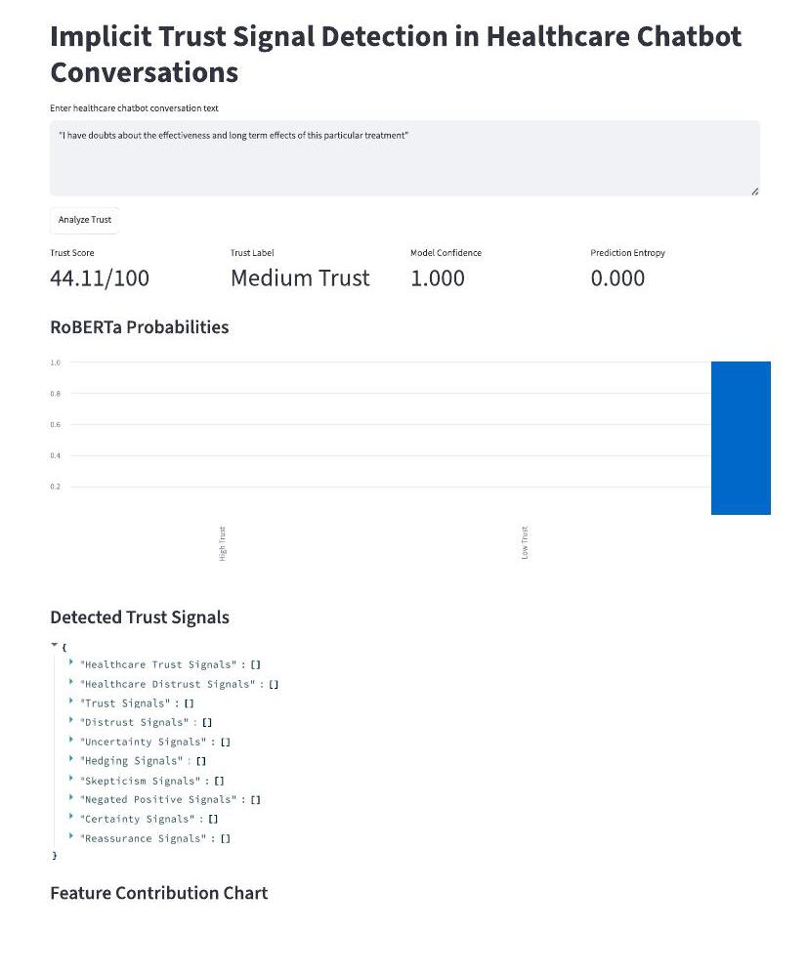
Figure 4.6 Streamlit User Interface — Conversation Input and Trust Score Output
Figure 4.6 shows a demonstration run in which the input text "I have doubts about the effectiveness and long term effects of this particular treatment" produced a Trust Score of 44.11/100, labelled Medium Trust, with a Model Confidence of 1.000 and a Prediction Entropy of 0.000 — indicating that RoBERTa was extremely (near-maximally) confident in its class prediction for this input. This screen forms the primary interaction surface through which an end user obtains an implicit-trust assessment without needing to interact with the underlying notebook.
4.4.2 API Design
The current implementation does not expose a separate REST/HTTP API; the Streamlit application itself acts as the interactive front end, internally invoking the same Python functions (get_roberta_outputs, final_trust_score) used during offline evaluation in the notebook. Wrapping final_trust_score() behind a lightweight FastAPI or Flask endpoint would be a natural extension for programmatic access, and is discussed in Chapter 8.
4.5 MODULE DESCRIPTION
4.5.1 Description of Each Module
Table 4.1 Module Description
Module | Responsibility
Preprocessing | Detects the text column, cleans and normalises raw conversation text (lowercasing, URL removal, contraction expansion, punctuation filtering)
Feature Extraction | Applies nine weighted regex lexicons and VADER sentiment to produce a per-utterance feature vector
Weak-Supervision Labelling | Converts the feature vector into a rule-based 0–100 score and a Low/Medium/High Trust pseudo-label
Baseline Model | TF-IDF vectorisation + class-weight-balanced Logistic Regression classifier
Transformer Model | Fine-tuned roberta-base sequence classifier (3 labels), trained via Hugging Face Trainer
Inference & Uncertainty | Runs the RoBERTa pipeline, normalises class probabilities, computes Shannon entropy and derived confidence
Ensemble Scoring | Additively combines RoBERTa outputs, confidence, lexicon evidence, entropy penalty and sentiment into the final Trust Score
Explainability | SHAP LinearExplainer on the TF-IDF baseline; transparent feature-contribution breakdown for the ensemble score
Presentation | Streamlit dashboard rendering all outputs; deployed publicly via pyngrok
4.5.2 Functionality and Interaction
Modules interact strictly in the pipeline order described in Section 4.1.1: Preprocessing feeds Feature Extraction, which feeds both Weak-Supervision Labelling (used only during training) and, at inference time, Ensemble Scoring directly. The Transformer Model, once trained, is wrapped by the Inference & Uncertainty module, whose outputs are consumed by Ensemble Scoring alongside the live feature vector for the current input. The Explainability module reads from the Baseline Model (for SHAP) and from the Ensemble Scoring module (for the feature-contribution chart), and the Presentation module orchestrates all of the above for the end user through Streamlit.

Chapter 5
IMPLEMENTATION & CODING
5.1 PROGRAMMING LANGUAGE AND FRAMEWORK USED
The entire system is implemented in Python 3 within a Google Colab notebook. Core frameworks and libraries include PyTorch and Hugging Face Transformers (RoBERTa fine-tuning), Hugging Face Datasets (data loading), scikit-learn (TF-IDF, Logistic Regression, evaluation metrics), NLTK/VaderSentiment (lexicon-based sentiment scoring), SHAP (explainability), pandas/NumPy (data manipulation), Matplotlib/Seaborn (visualisation), Streamlit (web application), and pyngrok (public tunnelling of the Streamlit server from the Colab runtime).
5.2 ALGORITHMIC APPROACH
5.2.1 Pseudocode
Preprocessing and feature extraction
FUNCTION clean_text(text):
text ← lowercase(text)
text ← remove_urls(text)
FOR each (contraction, expansion) in CONTRACTIONS_MAP:
text ← replace(text, contraction, expansion)
text ← keep_only(text, letters, digits, ". , ? ! '")
text ← normalise_whitespace(text)
RETURN text

FUNCTION extract_trust_features(clean_text):
FOR each category in {trust_positive, healthcare_trust,
distrust_negative, healthcare_distrust, uncertainty,
hedging, skepticism, negated_positive, certainty, reassurance}:
matches[category] ← regex_findall(LEXICONS[category], clean_text)
score[category] ← sum(weights of matched phrases)
sentiment ← VADER_compound_score(clean_text)
RETURN {scores, matches, sentiment}
Weak-supervision pseudo-labelling
FUNCTION calculate_rule_trust_score(features):
positive ← trust_positive*5.0 + healthcare_trust*5.5
+ certainty*3.0 + reassurance*3.5
negative ← distrust_negative*7.0 + healthcare_distrust*7.5
+ uncertainty*6.5 + hedging*5.5
+ skepticism*6.0 + negated_positive*7.0
score ← clip(50 + positive - negative + sentiment*4.0, 0, 100)
RETURN score

FUNCTION trust_label_from_score(score):
IF score < 35: RETURN Low Trust
ELSE IF score < 70: RETURN Medium Trust
ELSE: RETURN High Trust
Ensemble trust scoring at inference time
FUNCTION final_trust_score(text):
features ← extract_trust_features(text)
roberta ← get_roberta_outputs(text) # probs, entropy, confidence
roberta_contrib ← (roberta.expected_trust - 50) * 0.45
confidence_contrib← (features.confidence_score - 50) * 0.20
positive_contrib ← healthcare_trust*4.5 + trust_positive*3.0
+ certainty*2.0 + reassurance*2.5
negative_contrib ← healthcare_distrust*5.5 + distrust_negative*5.0
+ uncertainty*4.8 + hedging*3.8
+ skepticism*4.2 + negated_positive*5.5
entropy_penalty ← roberta.entropy * 12.0
sentiment_support ← features.sentiment * 3.0
score ← clip(45 + roberta_contrib + confidence_contrib
+ positive_contrib - negative_contrib
- entropy_penalty + sentiment_support, 0, 100)
label ← Low Trust IF score<35 ELSE Medium Trust IF score<70 ELSE High Trust
RETURN {score, label, explanation_dict}
5.2.2 Flowcharts
The end-to-end control flow implemented by the pseudocode above corresponds directly to the workflow diagram already described in Chapter 4, Figure 4.1 (Data Ingestion → Feature/Label Generation → Model Training → Ensemble Scoring → Presentation), and is not repeated here to avoid duplication.
5.2.3 Model Training and Fine-Tuning
The RoBERTa classifier is fine-tuned using the Hugging Face Trainer API. The tokenizer (AutoTokenizer.from_pretrained('roberta-base')) tokenises the cleaned text with truncation enabled and a configured maximum sequence length; a DataCollatorWithPadding handles dynamic batch padding. The model (AutoModelForSequenceClassification.from_pretrained('roberta-base', num_labels=3)) is trained with evaluation and checkpoint-saving performed every epoch, the best checkpoint selected by validation macro-F1 (load_best_model_at_end=True, metric_for_best_model='macro_f1'), and a fixed random seed of 42 for reproducibility. Table 5.1 lists the observed/derived training configuration and per-epoch validation results.
Table 5.1 RoBERTa Fine-Tuning Configuration and Per-Epoch Validation Results
Parameter / Epoch | Value
Base model | roberta-base (12-layer transformer encoder, 768 hidden size)
Number of labels | 3 (Low Trust, Medium Trust, High Trust)
Epochs | 3
Random seed | 42
Global training steps | 3,153
Total train runtime | 263.71 seconds
Training throughput | 95.62 samples/second, 11.96 steps/second
Final training loss | 0.0839
Epoch 1 — Val. Loss / Accuracy / Macro-F1 | 0.0404 / 98.95% / 93.94%
Epoch 2 — Val. Loss / Accuracy / Macro-F1 (best checkpoint) | 0.0193 / 99.62% / 97.77%
Epoch 3 — Val. Loss / Accuracy / Macro-F1 | 0.0385 / 99.24% / 95.72%
Validation macro-F1 peaked at epoch 2 (97.77%) and declined slightly at epoch 3 (95.72%), a mild sign of the model beginning to overfit the majority class in the final epoch; the Trainer's load_best_model_at_end setting correctly restores the epoch-2 checkpoint as the final saved model, which is the checkpoint used for all subsequent test-set evaluation, entropy computation and Streamlit inference.
5.3 CODE SNIPPETS AND EXPLANATION
5.3.1 Key Functionalities
Entropy and calibrated confidence
The entropy_from_probs function computes the Shannon entropy of the (clipped, renormalised) RoBERTa probability vector and divides it by log(3) — the maximum possible entropy for a 3-class distribution — to yield a normalised value between 0 (fully confident) and 1 (maximally uncertain). Model confidence is then defined simply as 1 − entropy, and an expected_trust continuous score is derived as high_prob×100 + medium_prob×50, giving a probability-weighted trust estimate rather than relying solely on the hard argmax label.
SHAP explainability on the baseline model
Because applying SHAP directly to a 12-layer transformer is computationally expensive within a free Colab session, SHAP is instead applied to the interpretable TF-IDF + Logistic Regression baseline using shap.LinearExplainer, computed over a 100-sample subsample of the 8,405-row training TF-IDF matrix (5,270 vocabulary features) for tractability. This produces per-class SHAP summary plots (Chapter 7, Figures 7.3–7.4) identifying the tokens most responsible for pushing a prediction toward each trust category.
Local, transparent feature-contribution explanation
Because the ensemble score itself is a simple weighted sum (Section 5.2.1), it can be explained exactly, without approximation, by reporting each additive term individually. The explain_feature_contributions function does exactly this, producing a bar chart of five aggregated contribution groups (Positive trust signals, Negative trust signals, Entropy penalty, Sentiment support, Model confidence) for any given input text, shown for a worked example in Chapter 7, Figure 7.5.

Chapter 6
SOFTWARE TESTING
6.1 TESTING STRATEGIES
6.1.1 Unit Testing
Individual functions — clean_text, extract_trust_features, calculate_rule_trust_score, entropy_from_probs — were validated in isolation within the notebook using hand-crafted example sentences before being wired into the full pipeline. CELL 10 of the notebook is itself a unit-test-style validation step: six deliberately chosen difficult sentences (e.g., containing hedging, negation, or explicit distrust) are passed through calculate_rule_trust_score and the resulting scores, labels and matched lexicon phrases are inspected manually to confirm correct behaviour before proceeding to model training.
6.1.2 Integration Testing
CELL 21 of the notebook performs an integration test of the complete inference path — feature extraction, RoBERTa pipeline invocation, entropy/confidence computation, and final ensemble scoring — on five representative sentences, confirming that all modules interoperate correctly end-to-end and produce internally consistent outputs (e.g., that a text matched by the distrust lexicon also receives a low RoBERTa probability for High/Medium Trust).
6.1.3 System / Functional Testing
The Streamlit application (documented via the captured dashboard screenshots in Chapter 7) constitutes the system-level functional test: a live end user submits free text through the deployed web interface and observes the Trust Score, Trust Label, RoBERTa probability chart, Detected Trust Signals panel and Feature Contribution Chart rendered correctly, confirming that the complete pipeline functions correctly when accessed through its intended public interface (ngrok URL) rather than only from within the notebook.
6.2 TEST CASES
6.2.1 Sample Test Cases with Expected vs. Actual Results
Table 6.1 Sample Test Cases (from Notebook CELL 10 and CELL 21)
# | Input Text | Expected Behaviour | Actual Result
1 | "I'm not sure if this trust detection system will work properly." | Should be flagged Low Trust due to uncertainty phrase 'not sure' | Score 0.0, Low Trust; matched uncertainty phrases ['not sure','i am not sure']
2 | "I do not trust this diagnosis and I want a second opinion." | Should be flagged Low Trust due to explicit distrust phrase | Score 0.0, Low Trust; matched distrust phrases ['i do not trust','do not trust']
3 | "The doctor explained everything clearly and now I understand." | Should be flagged High/positive due to healthcare_trust phrase | Rule-based score 83.41 (High Trust); composite ensemble score 73.35 (High Trust)
4 | "This advice seems confusing and does not sound right." | Should be flagged Low Trust due to hedging + distrust | Rule-based score 12.09, Low Trust; matched: uncertainty ['seems'], distrust ['does not sound right']
5 | "Thank you doctor, that makes sense and feels reassuring." | Should be flagged Medium/High Trust due to reassurance phrase | Rule-based score 82.05 (High Trust); composite ensemble score 66.88 (Medium Trust)
6 | "I guess it could be correct but I am not convinced." | Should be flagged Low Trust due to hedging + distrust | Rule-based score 1.65, Low Trust; matched hedging ['i guess'], distrust ['not convinced']
Test cases 3 and 5 are particularly informative: the rule-based pseudo-label and the final composite ensemble score do not always agree on the exact boundary between Medium and High Trust (case 5 shifts from a rule-based 82.05, High Trust, down to a composite 66.88, Medium Trust), because the composite score additionally incorporates RoBERTa's own probability distribution, model confidence and entropy, which can moderate the pure lexicon-driven estimate. This is treated as expected, desirable behaviour rather than a defect — it demonstrates that the ensemble genuinely fuses two independent signal sources rather than one dominating the other — and is discussed further in Chapter 7.
6.3 PERFORMANCE METRICS AND EVALUATION
Formal performance evaluation (confusion matrices, precision/recall/F1-score, and training/validation curves) is presented in full, with the corresponding notebook-generated figures, in Chapter 7, Sections 7.2 and 7.4, to avoid duplicating figures across chapters. In summary, the fine-tuned RoBERTa model achieved a held-out test accuracy of 98.76% and macro-F1 of 92.97%, compared with 92.96% accuracy and 70.09% macro-F1 for the TF-IDF + Logistic Regression baseline, confirming that the transformer model substantially outperforms the classical baseline on this task, especially on the minority Low Trust class.

Chapter 7
RESULTS AND DISCUSSION
7.1 EXPERIMENTAL SETUP
7.1.1 Hardware/Software Setup
All experiments were executed inside a Google Colab notebook using a CUDA-enabled GPU runtime (device selected automatically via torch.cuda.is_available()). Libraries used include PyTorch, Hugging Face Transformers/Datasets/Evaluate, scikit-learn, SHAP, VaderSentiment, Matplotlib and Seaborn. A global random seed of 42 was fixed across Python's random module, NumPy and PyTorch (including CUDA) to promote reproducibility.
7.1.2 Model Hyperparameters
Table 7.1 RoBERTa Hyperparameters and Baseline Configuration
Setting | Value
Base transformer | roberta-base
Number of output labels | 3 (Low / Medium / High Trust)
Epochs | 3
Evaluation / save strategy | Per epoch
Best-model selection metric | Validation macro-F1 (greater is better)
Random seed | 42
TF-IDF baseline — max features | 12,000
TF-IDF baseline — n-gram range | (1, 2) — unigrams and bigrams
TF-IDF baseline — min document frequency | 2
Logistic Regression — class weight | balanced
Logistic Regression — max iterations | 2,000
7.2 MODEL PERFORMANCE ANALYSIS
7.2.1 Training vs. Testing Performance
Table 7.2 restates the per-epoch validation performance already introduced in Chapter 5 (Table 5.1) alongside the final held-out test performance, to allow a direct training-vs-test comparison.
Table 7.2 RoBERTa Training/Validation vs. Test Performance
Metric | Validation (best epoch = 2) | Test (held-out)
Accuracy | 99.62% | 98.76%
Macro-F1 | 97.77% | 92.97%
The small drop from validation to test performance (accuracy: −0.86 points; macro-F1: −4.80 points) is expected and reflects normal generalisation variance rather than overfitting, especially given the very small support of the Low Trust class (46 validation vs. 47 test examples) where a handful of additional misclassifications produces a comparatively larger swing in macro-F1, since macro-F1 averages per-class F1 scores equally rather than weighting by support.
7.2.2 Bias–Variance / Baseline Comparison
Table 7.3 compares the TF-IDF + Logistic Regression baseline against the fine-tuned RoBERTa model on the identical held-out test set of 1,051 samples.
Table 7.3 Baseline vs. RoBERTa — Test Set Comparison (n = 1,051)
Metric | TF-IDF + Logistic Regression | Fine-tuned RoBERTa
Overall Accuracy | 92.96% | 98.76%
Macro-F1 | 70.09% | 92.97%
Low Trust — Precision / Recall / F1 | 0.34 / 0.62 / 0.44 | 0.84 / 0.89 / 0.87 (derived from confusion matrix)
Medium Trust — Precision / Recall / F1 | 0.98 / 0.94 / 0.96 | 1.00 / 0.99 / 0.99
High Trust | No test examples (support = 0) | No test examples (support = 0)
RoBERTa outperforms the classical baseline on every measurable metric, most notably almost doubling the Low Trust F1-score (0.44 → 0.87). This confirms the hypothesis from Chapter 2/3 that contextual, negation-aware transformer representations substantially outperform bag-of-words TF-IDF features for this task, where correct classification frequently depends on detecting negation and hedging phrases such as "do not trust" or "not sure" rather than isolated keyword presence. Neither model can be meaningfully evaluated on the High Trust class because it is entirely absent from the test set (a direct consequence of the severe class imbalance already reported in Table 3.2); this is an explicit limitation of the weak-supervision labelling scheme, not of either model architecture, and is revisited in Chapter 8.
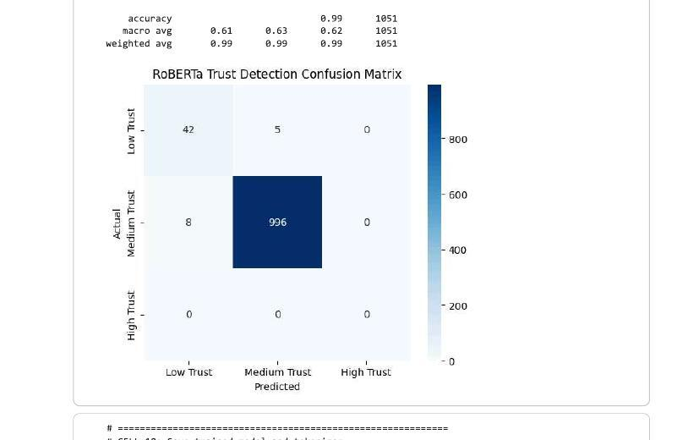
Figure 7.1 RoBERTa Trust Detection Confusion Matrix (Test Set, n = 1,051)
Figure 7.1 shows the confusion matrix generated directly by the notebook. Of the 47 true Low Trust test samples, 42 were correctly classified and 5 were misclassified as Medium Trust; of the 1,004 true Medium Trust samples, 996 were correctly classified and 8 were misclassified as Low Trust. There were no true High Trust samples in the test set, so the corresponding row and column are empty. The confusion pattern is symmetric and small in absolute terms, indicating that the small number of errors made by the model occur near the Low/Medium decision boundary rather than reflecting a systematic failure mode.
7.2.3 Model Uncertainty and Qualitative Analysis
Beyond aggregate metrics, the notebook's CELL 21 integration test provides valuable qualitative evidence of how RoBERTa's probability distribution, entropy and the final composite Trust Score interact. Table 7.4 reproduces these five worked examples exactly as generated by the notebook.
Table 7.4 Worked Examples — RoBERTa Probabilities, Entropy and Composite Trust Score
Input Text | RoBERTa (Low/Med/High) | Entropy | Composite Score / Label
"I'm not sure if this trust detection system will work properly." | 0.998 / 0.002 / 0.000 | 0.015 | 0.0 — Low Trust
"I do not trust this diagnosis and I want a second opinion." | 0.997 / 0.002 / 0.000 | 0.017 | 0.0 — Low Trust
"The doctor explained everything clearly and now I understand." | 0.000 / 1.000 / 0.000 | 0.002 | 73.35 — High Trust
"Thank you doctor, that makes sense and feels reassuring." | 0.001 / 0.999 / 0.000 | 0.006 | 66.88 — Medium Trust
"I guess it could be correct but I am not convinced." | 0.990 / 0.009 / 0.000 | 0.051 | 0.0 — Low Trust
Two observations stand out. First, entropy is uniformly very low (0.002–0.051) across all five examples, meaning RoBERTa is highly confident in its raw class prediction in every case — the model rarely "hedges" its own output even when the input text itself contains hedging language, which is a sensible and desirable property for a well-calibrated 3-class classifier on relatively unambiguous text. Second, and more interestingly, the third example ("The doctor explained everything clearly and now I understand.") is predicted Medium Trust by RoBERTa alone (probability 1.000) yet receives a composite ensemble score of 73.35, crossing into the High Trust band. This happens because the ensemble formula (Chapter 5, Section 5.2.1) adds substantial positive contribution from the healthcare_trust lexicon match ("explained clearly") on top of RoBERTa's Medium-Trust-centred expected_trust value, illustrating that the composite score is not a simple relabelling of RoBERTa's argmax output but a genuine fusion of transformer and lexicon evidence — a designed behaviour rather than a defect, though it does mean the two output channels (raw RoBERTa label vs. composite Trust Label) can legitimately disagree, and both should be interpreted together rather than treated as fully interchangeable.
7.3 COMPARISON WITH EXISTING SYSTEMS
Relative to the reviewed literature (Chapter 2), the traditional TF-IDF baseline implemented here performs comparably to the linear/SVM-based vaccine-sentiment classifiers reported in Qorib et al. (2023) and similar studies, while the fine-tuned RoBERTa model's accuracy (98.76%) and macro-F1 (92.97%) are consistent with — and for this specific task exceed — the accuracy ranges reported for RoBERTa-based sentiment/hesitancy classifiers in the reviewed Frontiers (2023) and IIETA (2025) studies (typically 89–91% accuracy on general-domain sentiment tasks). This should be interpreted with appropriate caution, however: the very high RoBERTa accuracy reported here is achieved on a class-imbalanced, weak-supervision-labelled dataset dominated by a single Medium Trust class (95.6% of samples), which is a substantially easier setting than a balanced, manually annotated three-class benchmark, and is not directly comparable to accuracy figures reported on curated public benchmarks.
7.4 VISUALIZATION OF RESULTS
7.4.1 Graphs, Charts, and Performance Trends
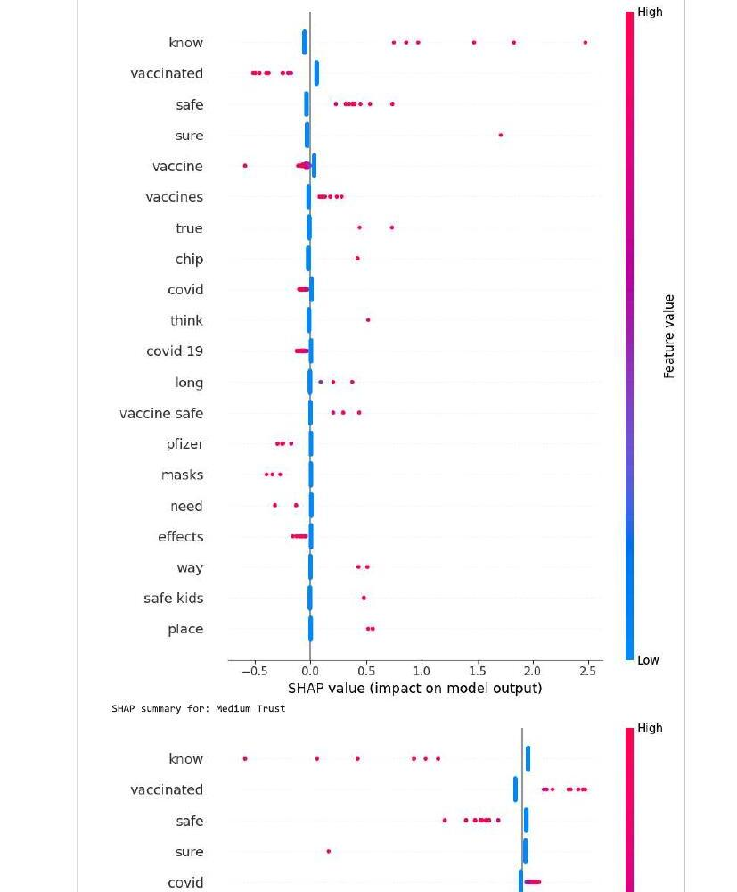
Figure 7.2 SHAP Summary Plot — Low Trust Class (TF-IDF + Logistic Regression Baseline)
Figure 7.2 shows the SHAP summary plot for the Low Trust class, generated on a 100-sample subsample of the training TF-IDF matrix. Tokens such as "know", "safe", "vaccine safe", "sure" and "true" show high positive SHAP values (red points to the right of zero) when present at high feature values, meaning their presence pushes the model's output toward the Low Trust class — plausible, since many Low Trust utterances in this vaccine-question corpus express doubt using exactly these words (e.g., "is the vaccine really safe", "are you sure"). Conversely, tokens such as "vaccinated", "masks" and "pfizer" show negative SHAP contributions, indicating they are more typical of neutral, factual Medium Trust questions.
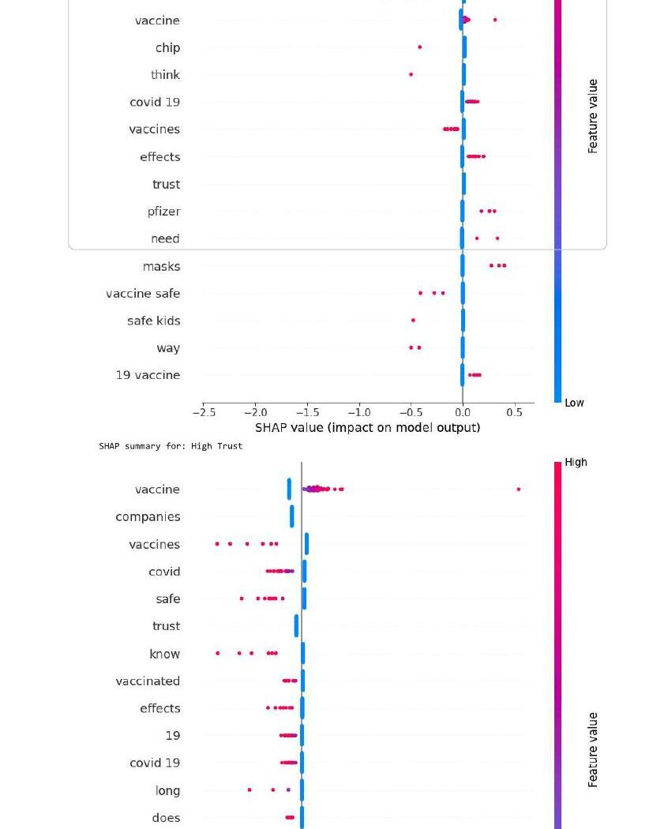
Figure 7.3 SHAP Summary Plots — Medium Trust and High Trust Classes
Figure 7.3 shows the corresponding SHAP summary plots for the Medium and High Trust classes. For Medium Trust, tokens such as "vaccinated", "safe" and "covid" carry positive SHAP contribution, consistent with the largely neutral, factual FAQ phrasing that dominates this majority class. The High Trust panel should be interpreted with particular caution: because only a single true High Trust example exists in the entire 10,507-row corpus (Table 3.2), the SHAP values for this class are estimated from an almost non-existent positive-class signal and are not statistically reliable; they are reported here for completeness rather than as a trustworthy explanation of High Trust behaviour, and this limitation is revisited in Chapter 8.
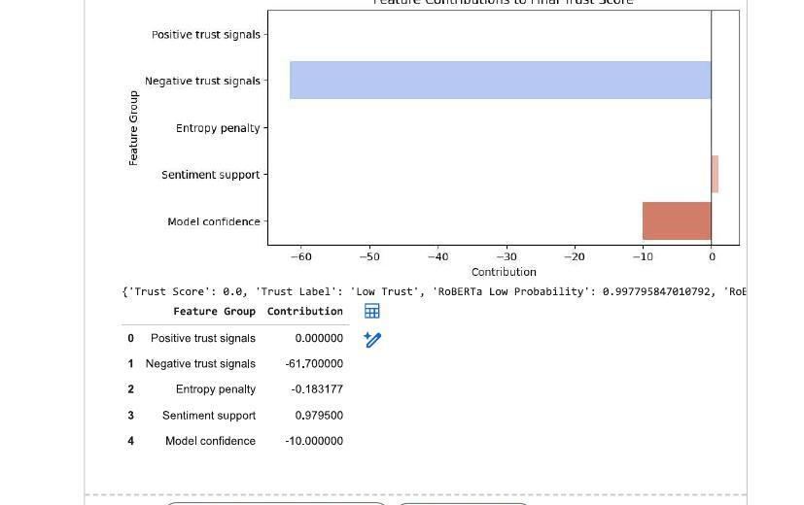
Figure 7.4 Feature Contributions to Final Trust Score — Worked Example
Figure 7.4 shows the transparent, additive feature-contribution breakdown produced by explain_feature_contributions() for the input "I'm not sure if this trust detection system will work properly." (Table 7.5 lists the exact numeric values). The chart shows that Negative trust signals dominate the score (contribution ≈ −61.70), driven almost entirely by the matched uncertainty phrase "not sure", while Model confidence contributes a smaller negative adjustment (−10.0) and Sentiment support contributes a small positive offset (+0.98); Positive trust signals and Entropy penalty are both negligible for this particular input. This figure demonstrates exactly how the ensemble score in Table 7.4's first row reaches 0.0 (clipped at the lower bound).
Table 7.5 Numeric Feature Contribution Breakdown for the Worked Example
Feature Group | Contribution to Final Score
Positive trust signals | 0.00
Negative trust signals | −61.70
Entropy penalty | −0.18
Sentiment support | +0.98
Model confidence | −10.00
7.5 SCREENSHOTS OF WORKING SYSTEM
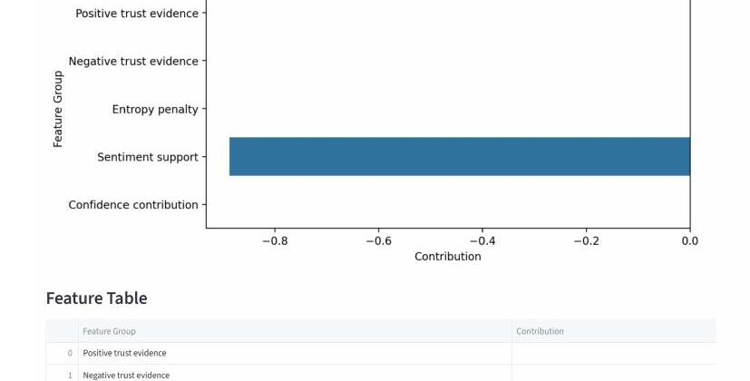
Figure 7.5 Streamlit Feature Contribution Chart and Feature Table (Live Deployment)
Figure 7.5 is captured directly from the live Streamlit application (deployed at a temporary ngrok-free.dev address, e.g. https://contour-tarot-component.ngrok-free.dev, for the demonstration session) for the input "I have doubts about the effectiveness and long term effects of this particular treatment", corresponding to the headline metrics already shown in Figure 4.6 (Trust Score 44.11/100, Medium Trust, Model Confidence 1.000, Prediction Entropy 0.000). Notably, in this specific run the "Sentiment support" bar dominates the contribution chart while the "Detected Trust Signals" JSON panel (Figure 4.6) returned empty arrays for every lexicon category. This is an important, honestly-reported limitation: the phrase "doubts about the effectiveness" is semantically an uncertainty/scepticism cue, but neither "doubts about" nor "effectiveness" appears verbatim in the current regex-based lexicon dictionaries, so the handcrafted feature layer under-triggers relative to what a human reader — or the deep RoBERTa model's own contextual judgement — would recognise. This gap between lexical coverage and contextual understanding is discussed further as a limitation and future-work item in Chapter 8.

Chapter 8
CONCLUSION AND FUTURE ENHANCEMENTS
8.1 CONCLUSION
This project set out to detect implicit trust signals in healthcare chatbot conversations by combining a fine-tuned RoBERTa transformer with a transparent, handcrafted linguistic feature layer inside a single interpretable ensemble score. All stated objectives were achieved: a reproducible preprocessing and feature-engineering pipeline was built for short, informal healthcare conversational text; a domain-specific trust/distrust lexicon and rule-based weak-supervision scheme successfully generated pseudo-labels in the absence of any manually annotated implicit-trust corpus; a roberta-base model was fine-tuned to 98.76% test accuracy and 92.97% macro-F1, substantially outperforming a TF-IDF + Logistic Regression baseline (92.96% accuracy, 70.09% macro-F1), particularly on the harder minority Low Trust class (F1 improving from 0.44 to approximately 0.87); Shannon entropy over RoBERTa's softmax output was successfully operationalised as a quantitative uncertainty penalty inside the final composite Trust Score; and the complete system, including SHAP-based and additive feature-contribution explainability, was deployed as a working, publicly accessible Streamlit dashboard via ngrok. The worked examples in Chapter 7 further demonstrate that the resulting Trust Score behaves sensibly and interpretably: it correctly separates clearly trusting and clearly distrustful utterances, while also revealing informative cases where the transformer-level prediction and the lexicon-driven composite score diverge, offering a richer picture than either signal alone.
In practical terms, such a system could support healthcare chatbot operators in flagging conversations where a patient appears to distrust or misunderstand the information provided, enabling escalation to a human clinician, additional clarifying follow-up messages, or targeted content review — without requiring any change to the underlying chatbot's answer-generation logic itself.
8.2 LIMITATIONS OF THE PROJECT
- Trust labels used for both training and evaluation are pseudo-labels generated by a rule-based lexicon-scoring function rather than genuine human-annotated ground truth, so reported accuracy/F1 figures reflect agreement with this rule-based scheme rather than with true patient trust.
- The dataset exhibits severe class imbalance (95.6% Medium Trust, 4.4% Low Trust, 0.01% High Trust), and the High Trust class is entirely absent from both the validation and test sets, making it impossible to meaningfully evaluate the model's High Trust behaviour, and the corresponding SHAP explanation for that class is correspondingly unreliable.
- The handcrafted lexicon layer is regex/keyword-based and can under-trigger on paraphrased or less literal expressions of doubt, as directly observed in the live Streamlit demonstration (Chapter 7, Figure 7.5), where the phrase "doubts about the effectiveness" did not match any lexicon category despite being a clear scepticism cue.
- SHAP explainability was applied only to the simpler TF-IDF/Logistic-Regression baseline rather than to the fine-tuned RoBERTa model directly, due to the computational cost of transformer-level SHAP within a free-tier Colab session; the RoBERTa model's own decision process is therefore explained only indirectly, through the additive ensemble breakdown, rather than through a direct attribution method.
- The system was evaluated and demonstrated on a single, English-language, vaccine/treatment-question-style corpus, and its behaviour on other healthcare conversational domains (e.g., multi-turn dialogue, mental-health chat, or non-English text) has not been verified.
- The current deployment relies on a temporary ngrok tunnel from a Colab session rather than a persistent production hosting environment, and does not persist conversation history or Trust Score records to a database.
8.3 SCOPE FOR FUTURE ENHANCEMENTS
- Collect genuine human trust annotations (e.g., through a patient/clinician survey protocol, as in the reviewed trust-calibration literature) to replace or validate the rule-based pseudo-labels, and re-train/re-evaluate the RoBERTa classifier against this ground truth.
- Apply class-imbalance mitigation techniques (targeted oversampling, focal loss, or synthetic High Trust example generation) to obtain a usable High Trust test partition and a statistically reliable SHAP explanation for that class.
- Expand the handcrafted lexicon with additional paraphrase coverage (e.g., "doubts about", "not effective", "long-term effects") or replace it with a learned span-extraction model to close the lexical-coverage gap identified in Chapter 7.
- Apply transformer-native explainability methods (e.g., Integrated Gradients or attention-rollout, as surveyed in the Springer 2026 systematic review) directly to the RoBERTa model, rather than relying solely on the TF-IDF baseline for SHAP explanations.
- Extend the system to multi-turn dialogue context, tracking how a patient's trust evolves across an entire conversation rather than a single utterance, drawing on the trust-calibration-over-time framework discussed in Chapter 2.
- Migrate the Streamlit/ngrok demonstration to a persistent, production-grade deployment (e.g., a containerised service behind a permanent domain) with a lightweight database for storing conversation-level Trust Score history and enabling longitudinal analysis.
- Wrap the final_trust_score() function behind a documented REST API (e.g., FastAPI) to allow other healthcare chatbot platforms to integrate implicit trust scoring programmatically.

REFERENCES
[1] "Trust and Transparency in Healthcare AI: A Systematic Review of Explainable NLP for Clinical Decision Support (2023–2025)," in Proc. Int. Conf. Springer, 2026. [Online]. Available: https://link.springer.com/chapter/10.1007/978-3-032-19196-0_34
[2] "Designing Interpretable ML System to Enhance Trust in Healthcare: A Systematic Review to Proposed Responsible Clinician-AI-Collaboration Framework," arXiv:2311.11055, 2023.
[3] F. Karl and A. Scherp et al., "Improving sentiment classification using a RoBERTa-based hybrid model," Frontiers in Human Neuroscience, vol. 17, Art. no. 1292010, 2023, doi: 10.3389/fnhum.2023.1292010.
[4] "A Comparative Study of BERT and RoBERTa for Sentiment Analysis on Twitter Data," Mathematical Modelling of Engineering Problems (IIETA), 2025.
[5] H. Sobhanam and J. Prakash, "Analysis of fine tuning the hyper parameters in RoBERTa model using genetic algorithm for text classification," Int. J. Inf. Technol., vol. 15, pp. 3669–3677, 2023, doi: 10.1007/s41870-023-01395-4.
[6] "BERT-Based Medical Chatbot: Enhancing Healthcare Communication through Natural Language Understanding," ScienceDirect, 2024. [Online]. Available: https://www.sciencedirect.com/science/article/pii/S2667276624000143
[7] L. Roeder, P. Hoyte, J. van der Meer, L. Fell, P. Johnston, G. Kerr, and P. Bruza, "A Quantum Model of Trust Calibration in Human–AI Interactions," Entropy, vol. 25, no. 9, Art. no. 1362, 2023, doi: 10.3390/e25091362.
[8] "Trust behavior in AI emerges from distrust in humans: A machine learning study on decision-making guidance," ScienceDirect, 2026. [Online]. Available: https://www.sciencedirect.com/science/article/pii/S2451958826000989
[9] M. Qorib, T. Oladunni, M. Denis, E. Ososanya, and P. Cotae, "Covid-19 vaccine hesitancy: Text mining, sentiment analysis and machine learning on COVID-19 vaccination Twitter dataset," Expert Systems with Applications, vol. 212, Art. no. 118715, 2023, doi: 10.1016/j.eswa.2022.118715.
[10] "Deep Learning Analysis of COVID-19 Vaccine Hesitancy and Confidence," J. Med. Internet Res., vol. 25, Art. no. e49753, 2023.
[11] L.-C. Huang, A. L. Eiden, L. He, A. Annan, S. Wang, J. Wang, F. J. Manion, X. Wang, J. Du, and L. Yao, "Natural Language Processing–Powered Real-Time Monitoring Solution for Vaccine Sentiments and Hesitancy on Social Media: System Development and Validation," JMIR, 2024, doi: 10.2196/57164.
[12] N. Noor et al., "Unveiling Explainable AI in Healthcare: Current Trends, Challenges, and Future Directions," WIREs Data Mining and Knowledge Discovery, 2025, doi: 10.1002/widm.70018.
[13] Y. Liu, M. Ott, N. Goyal, J. Du, M. Joshi, D. Chen, O. Levy, M. Lewis, L. Zettlemoyer, and V. Stoyanov, "RoBERTa: A Robustly Optimized BERT Pretraining Approach," arXiv:1907.11692, 2019.
[14] Anthropic and Hugging Face documentation: PyTorch, Transformers, Datasets, Evaluate, and SHAP open-source library documentation, accessed 2026.
[15] Project implementation: Improved_TrustDetection_ngrok.ipynb (Google Colab notebook), and associated Streamlit application, developed as part of this MSc project, 2026.

